PYTHON PROJECT



Submitted by
Name Surname: Aishwarya Sah
Student ID: 9951
Computing
Kathmandu, Nepal
April , 2023

Project Report: Student Profile System
1. Introduction
This project is developed by using python programming language and it aims to provide a basic user friendly experience for admin, student and teacher. Object orientation Programming concepts such as objects, constructor , inheritance are used to implement with csv and txt files for file handling.
The principle that are used mentioned below:
Classes:
Login window : log in window where user can select their role
Admin login window , Teacher login window , Student log in window handles the login function for admin, teacher, and student respectively. Admin Dashboard , Teacher Dashboard and Student Dashboard are the dashboards for admin, teacher, and student respectively.

Constructor (__init__ function) : To initialize the objects with the proper properties, constructors are used in each class (__init__ function).

Function : Throughout the code, functions are used for a various purposes such as for
login, add, remove, edit, password, publish notice, approve leave, edit student information, edit teacher information, edit eca, edit eca marks, edit subject marks, edit password Certain operations or dashboard functionality and so on other are managed by these functions.
functions also load_data and write_data are used to load and write data to CSV files.

CSV files : They are used to store data related to users, grades, ECAs, notices, etc.

TXT files : They are used to store passwords,leave message and notice.

Error Handling: Try-except blocks are used to handle failures such as unexpected errors, invalid input, and file not found (FileNotFoundError). Try-except blocks are used in all functions that manipulate data or operate on files in order to manage possible problems.
The user sees specific error messages that help explain what went wrong and how to fix it.

Message Box Alerts: Message box alerts (messagebox.showerror or messagebox.showinfo) are used to show error notifications to the user.

Main(): main() creates an instance of the LoginWindow class and starts the main event loop with root in order to initialise the Tkinter application.loop().

Source code of admin, teacher and student :
import tkinter as tk
from tkinter import simpledialog, messagebox
import matplotlib.pyplot as plt
import csv

STUDENT_DATABASE = 'students.csv'
TEACHER_DATABASE = 'teacherss.csv'
ECA_DATABASE = 'eca1.csv'
GRADES_DATABASE = 'grades.csv'

class LoginWindow:
def _init_(self):
self.root = tk.Tk()
self.root.title("Login")

self.frame = tk.Frame(self.root, bg="#CFFFE5", padx=20, pady=20, bd=2, relief=tk.GROOVE)
self.frame.pack()

self.label = tk.Label(self.frame, text="Choose login role:", bg="#CFFFE5")
self.label.grid(row=0, columnspan=2, padx=5, pady=5)

self.button_admin = tk.Button(self.frame, text="Admin", command=self.admin_login, bg="#00B5A5", fg="white", bd=1)
self.button_admin.grid(row=1, column=0, padx=5, pady=5)

self.button_teacher = tk.Button(self.frame, text="Teacher", command=self.teacher_login, bg="#00B5A5", fg="white", bd=1)
self.button_teacher.grid(row=1, column=1, padx=5, pady=5)

self.button_student = tk.Button(self.frame, text="Student", command=self.student_login, bg="#00B5A5", fg="white", bd=1)
self.button_student.grid(row=2, column=0, columnspan=2, padx=5, pady=5)

self.button_exit = tk.Button(self.frame, text="Exit", command=self.root.destroy, bg="#00B5A5", fg="white", bd=1)
self.button_exit.grid(row=3, columnspan=2, padx=5, pady=5)

def admin_login(self):
self.root.destroy()
AdminLoginWindow(self.root)

def teacher_login(self):
self.root.destroy()
TeacherLoginWindow(self.root)

def student_login(self):
self.root.destroy()
StudentLoginWindow(self.root)

class AdminLoginWindow:
def _init_(self, root):
self.root = root
self.root.title("Admin Login")

self.frame = tk.Frame(self.root, bg="#CFFFE5", padx=20, pady=20, bd=2, relief=tk.GROOVE)
self.frame.pack()

self.label_username = tk.Label(self.frame, text="Username:", bg="#CFFFE5")
self.label_username.grid(row=0, column=0, padx=5, pady=5)
self.entry_username = tk.Entry(self.frame, bd=1)
self.entry_username.grid(row=0, column=1, padx=5, pady=5)

self.label_password = tk.Label(self.frame, text="Password:", bg="#CFFFE5")
self.label_password.grid(row=1, column=0, padx=5, pady=5)
self.entry_password = tk.Entry(self.frame, show="*", bd=1)
self.entry_password.grid(row=1, column=1, padx=5, pady=5)

self.button_login = tk.Button(self.frame, text="Login", command=self.login, bg="#00B5A5", fg="white", bd=1)
self.button_login.grid(row=2, columnspan=2, padx=5, pady=5)

def login(self):
username = self.entry_username.get()
password = self.entry_password.get()

# Implement your authentication logic here for admin
if username == "aishwarya" and password == "ash@123":
messagebox.showinfo("Success", "Admin login successful!")
self.root.destroy()
AdminDashboard()
else:
messagebox.showerror("Error", "Invalid username or password")

class TeacherLoginWindow:
def _init_(self, root):
self.root = root
self.root.title("Teacher Login")

self.frame = tk.Frame(self.root, bg="#CFFFE5", padx=20, pady=20, bd=2, relief=tk.GROOVE)
self.frame.pack()

self.label_id = tk.Label(self.frame, text="Teacher ID:", bg="#CFFFE5")
self.label_id.grid(row=0, column=0, padx=5, pady=5)
self.entry_id = tk.Entry(self.frame, bd=1)
self.entry_id.grid(row=0, column=1, padx=5, pady=5)

self.label_password = tk.Label(self.frame, text="Password:", bg="#CFFFE5")
self.label_password.grid(row=1, column=0, padx=5, pady=5)
self.entry_password = tk.Entry(self.frame, show="*", bd=1)
self.entry_password.grid(row=1, column=1, padx=5, pady=5)

self.button_login = tk.Button(self.frame, text="Login", command=self.login, bg="#00B5A5", fg="white", bd=1)
self.button_login.grid(row=2, columnspan=2, padx=5, pady=5)

class User:
def _init_(self, fullname, role):
self.fullname = fullname
self.role = role

class Teacher(User):
def init(self, fullname, role, email=None, password=None):
super().init(fullname, role)
self.email = email
self.password = password

def teacher_login(entry_fullname, entry_password, login_window):
try:
# Prompting user for input
fullname = entry_fullname.get()
password = entry_password.get()

# Reading teacher password from CSV file
with open(TEACHER_DATABASE, mode='r') as file:
reader = csv.DictReader(file)
for row in reader:
if row['fullname'] == fullname and row['passsword'] == password:
# If the entered credentials match, call the teacher_dashboard function
login_window.destroy() # Close the login window
teacher_dashboard(fullname)
return # Exit the function if login is successful

# If the loop completes without finding a matching fullname and password
messagebox.showerror("Error", "Invalid fullname or password. Please try again.")
except FileNotFoundError:
messagebox.showerror("Error", "Teacher credentials file not found.")
except Exception as e:
messagebox.showerror("Error", f"An unexpected error occurred: {e}")

class LoginWindow:
def student_login(self):
self.root.destroy()
StudentLoginWindow()

class StudentLoginWindow:
def _init_(self):
self.root = tk.Tk()
self.root.title("Student Login")

self.frame = tk.Frame(self.root, bg="#CFFFE5", padx=20, pady=20, bd=2, relief=tk.GROOVE)
self.frame.pack()

self.label_id = tk.Label(self.frame, text="Student ID:", bg="#CFFFE5")
self.label_id.grid(row=0, column=0, padx=5, pady=5)
self.entry_id = tk.Entry(self.frame, bd=1)
self.entry_id.grid(row=0, column=1, padx=5, pady=5)

self.label_password = tk.Label(self.frame, text="Password:", bg="#CFFFE5")
self.label_password.grid(row=1, column=0, padx=5, pady=5)
self.entry_password = tk.Entry(self.frame, show="*", bd=1)
self.entry_password.grid(row=1, column=1, padx=5, pady=5)

self.button_login = tk.Button(self.frame, text="Login", command=self.login, bg="#00B5A5", fg="white", bd=1)
self.button_login.grid(row=2, columnspan=2, padx=5, pady=5)

def login(self):
student_id = self.entry_id.get()
password = self.entry_password.get()

# Implement your authentication logic here for student
try:
with open("users.csv", newline='') as users_file:
reader = csv.DictReader(users_file)
for row in reader:
if row["student_id"] == student_id and row["password"] == password:
messagebox.showinfo("Success", "Student login successful!")
self.root.destroy()
StudentDashboard()
return
except FileNotFoundError:
messagebox.showerror("Error", "Student data file not found")
return
messagebox.showerror("Error", "Invalid ID or password")

class AdminDashboard:
def _init_(self):
self.root = tk.Tk()
self.root.title("Admin Dashboard")
self.create_widgets()

def create_widgets(self):
self.label = tk.Label(self.root, text="Admin Dashboard", font=("Helvetica", 16))
self.label.pack(pady=10)

self.button_add_student = tk.Button(self.root, text="Add Student", command=self.add_student, bg="#00B5A5", fg="white", bd=1)
self.button_add_student.pack(pady=5, fill=tk.X)

self.button_delete_student = tk.Button(self.root, text="Delete Student", command=self.delete_student, bg="#00B5A5", fg="white", bd=1)
self.button_delete_student.pack(pady=5, fill=tk.X)

self.button_edit_eca = tk.Button(self.root, text="Edit ECA", command=self.edit_eca, bg="#98FF98", fg="white", bd=2)
self.button_edit_eca.pack(pady=5, fill=tk.X)

self.button_edit_eca_marks = tk.Button(self.root, text="Edit ECA Marks", command=self.edit_eca_marks, bg="#00B5A5", fg="white", bd=1)
self.button_edit_eca_marks.pack(pady=5, fill=tk.X)

self.button_edit_subject_marks = tk.Button(self.root, text="Edit Subject Marks", command=self.edit_subject_marks, bg="#00B5A5", fg="white", bd=1)
self.button_edit_subject_marks.pack(pady=5, fill=tk.X)

self.button_edit_password = tk.Button(self.root, text="Edit Password", command=self.edit_password, bg="#00B5A5", fg="white", bd=1)
self.button_edit_password.pack(pady=5, fill=tk.X)

self.button_edit_student_info = tk.Button(self.root, text="Edit Student Info", command=self.edit_student_info, bg="#00B5A5", fg="white", bd=1)
self.button_edit_student_info.pack(pady=5, fill=tk.X)

self.button_edit_teacher_info = tk.Button(self.root, text="Edit Teacher Info", command=self.edit_teacher_info, bg="#00B5A5", fg="white", bd=1)
self.button_edit_teacher_info.pack(pady=5, fill=tk.X)

self.button_publish_notice = tk.Button(self.root, text="Publish Notice", command=self.publish_notice, bg="#00B5A5", fg="white", bd=1)
self.button_publish_notice.pack(pady=5, fill=tk.X)

self.button_approve_leave = tk.Button(self.root, text="Approve Leave", command=self.approve_leave, bg="#00B5A5", fg="white", bd=1)
self.button_approve_leave.pack(pady=5, fill=tk.X)

self.button_exit = tk.Button(self.root, text="Exit", command=self.root.destroy, bg="#00B5A5", fg="white", bd=1)
self.button_exit.pack(pady=10, fill=tk.X)

def add_student(self):
def submit():
username = entry_username.get()
password = entry_password.get()
student_id = entry_id.get()
section = entry_section.get()
subject = entry_subject.get()
email = entry_email.get()
address = entry_address.get()
gender = entry_gender.get()

try:
with open("users.csv", "a", newline='') as users_file:
csv_writer = csv.writer(users_file)
csv_writer.writerow([username, password, "student", student_id, section, subject, email, address, gender])

messagebox.showinfo("Success", "Student added successfully.")
add_window.destroy()
except Exception as e:
messagebox.showerror("Error", f"An unexpected error occurred: {e}")

add_window = tk.Toplevel()
add_window.title("Add Student")

label_username = tk.Label(add_window, text="Username:")
label_username.grid(row=0, column=0, padx=5, pady=5)
entry_username = tk.Entry(add_window)
entry_username.grid(row=0, column=1, padx=5, pady=5)

label_password = tk.Label(add_window, text="Password:")
label_password.grid(row=1, column=0, padx=5, pady=5)
entry_password = tk.Entry(add_window, show="*")
entry_password.grid(row=1, column=1, padx=5, pady=5)

label_id = tk.Label(add_window, text="ID:")
label_id.grid(row=2, column=0, padx=5, pady=5)
entry_id = tk.Entry(add_window)
entry_id.grid(row=2, column=1, padx=5, pady=5)

label_section = tk.Label(add_window, text="Section:")
label_section.grid(row=3, column=0, padx=5, pady=5)
entry_section = tk.Entry(add_window)
entry_section.grid(row=3, column=1, padx=5, pady=5)

label_subject = tk.Label(add_window, text="Subject:")
label_subject.grid(row=4, column=0, padx=5, pady=5)
entry_subject = tk.Entry(add_window)
entry_subject.grid(row=4, column=1, padx=5, pady=5)

label_email = tk.Label(add_window, text="Email:")
label_email.grid(row=5, column=0, padx=5, pady=5)
entry_email = tk.Entry(add_window)
entry_email.grid(row=5, column=1, padx=5, pady=5)

label_address = tk.Label(add_window, text="Address:")
label_address.grid(row=6, column=0, padx=5, pady=5)
entry_address = tk.Entry(add_window)
entry_address.grid(row=6, column=1, padx=5, pady=5)

label_gender = tk.Label(add_window, text="Gender:")
label_gender.grid(row=7, column=0, padx=5, pady=5)
entry_gender = tk.Entry(add_window)
entry_gender.grid(row=7, column=1, padx=5, pady=5)

submit_button = tk.Button(add_window, text="Submit", command=submit)
submit_button.grid(row=8, columnspan=2, padx=5, pady=5)

def delete_student(self):
def submit():
student_id = entry_student_id.get()

# Implement logic to delete student from CSV file
try:
with open("users.csv", "r") as file:
lines = file.readlines()
with open("users.csv", "w") as file:
for line in lines:
if student_id not in line:
file.write(line)

messagebox.showinfo("Success", f"Student with ID {student_id} deleted successfully.")
delete_window.destroy()
except Exception as e:
messagebox.showerror("Error", f"An unexpected error occurred: {e}")

delete_window = tk.Toplevel()
delete_window.title("Delete Student")

label_student_id = tk.Label(delete_window, text="Student ID:")
label_student_id.grid(row=0, column=0, padx=5, pady=5)
entry_student_id = tk.Entry(delete_window)
entry_student_id.grid(row=0, column=1, padx=5, pady=5)

submit_button = tk.Button(delete_window, text="Submit", command=submit)
submit_button.grid(row=1, columnspan=2, padx=5, pady=5)

def edit_eca(self):
ecas_data = self.load_data("eca1.csv")
if not ecas_data:
return

eca_id = simpledialog.askstring("Edit ECA", "Enter the ID of the ECA to edit:")
if not eca_id:
return

eca = None
for row in ecas_data:
if row['id'] == eca_id:
eca = row
break

if not eca:
messagebox.showerror("Error", "ECA ID not found.")
return

new_eca = simpledialog.askstring("Edit ECA", "Enter the new ECA:")
if not new_eca:
return

eca['eca'] = new_eca
self.write_data(ecas_data, "eca1.csv")

messagebox.showinfo("Success", "ECA updated successfully.")

def edit_eca_marks(self):
eca_marks_data = self.load_data("eca1.csv")
if not eca_marks_data:
return

eca_marks_id = simpledialog.askstring("Edit ECA Marks", "Enter the ID of the ECA marks to edit:")
if not eca_marks_id:
return

eca_marks = None
for row in eca_marks_data:
if row['id'] == eca_marks_id:
eca_marks = row
break

if not eca_marks:
messagebox.showerror("Error", "ECA Marks ID not found.")
return

new_eca_marks = simpledialog.askstring("Edit ECA Marks", "Enter the new ECA marks:")
if not new_eca_marks:
return

eca_marks['marks'] = new_eca_marks
self.write_data(eca_marks_data, "eca1.csv")

messagebox.showinfo("Success", "ECA Marks updated successfully.")

def edit_subject_marks(self):
subject_marks_data = self.load_data("grades.csv")
if not subject_marks_data:
return

subject_id = simpledialog.askstring("Edit Subject Marks", "Enter the ID of the subject to edit marks for:")
if not subject_id:
return

subject = None
for row in subject_marks_data:
if row['id'] == subject_id:
subject = row
break

if not subject:
messagebox.showerror("Error", "Subject ID not found.")
return

new_marks = simpledialog.askstring("Edit Subject Marks", "Enter the new marks:")
if not new_marks:
return

subject['marks'] = new_marks
self.write_data(subject_marks_data, "grades.csv")

messagebox.showinfo("Success", "Subject marks updated successfully.")

def edit_password(self):
password_data = self.load_data("passwords.csv")
if not password_data:
return

password_data_id = simpledialog.askstring("Edit password", "Enter the ID of the password to edit:")
if not password_data_id:
return

password = None
for row in password_data:
if row['id'] == password_data_id:
password = row
break

if not password:
messagebox.showerror("Error", "password ID not found.")
return

new_password = simpledialog.askstring("Edit password", "Enter the new password:")
if not password:
return

password['marks'] = new_password
self.write_data(password_data, "passwords.csv")

messagebox.showinfo("Success", "password updated successfully.")

def edit_student_info(self):
students_data = self.load_data("users.csv")
if not students_data:
return

student_id = simpledialog.askstring("Edit Student Info", "Enter the ID of the student to edit info for:")
if not student_id:
return

student = None
for row in students_data:
if row['id'] == student_id:
student = row
break

if not student:
messagebox.showerror("Error", "Student ID not found.")
return

# Ask for new student details
new_name = simpledialog.askstring("Edit Student Info", "Enter the new name:")
if not new_name:
return

new_email = simpledialog.askstring("Edit Student Info", "Enter the new email:")
if not new_email:
return

student['name'] = new_name
student['email'] = new_email
self.write_data(students_data, "users.csv")

messagebox.showinfo("Success", "Student info updated successfully.")

def edit_teacher_info(self):
teachers_data = self.load_data("teacher.csv")
if not teachers_data:
return

teacher_id = simpledialog.askstring("Edit Teacher Info", "Enter the ID of the teacher to edit info for:")
if not teacher_id:
return

teacher = None
for row in teachers_data:
if row['id'] == teacher_id:
teacher = row
break

if not teacher:
messagebox.showerror("Error", "Teacher ID not found.")
return

# Ask for new teacher details
new_name = simpledialog.askstring("Edit Teacher Info", "Enter the new name:")
if not new_name:
return

new_email = simpledialog.askstring("Edit Teacher Info", "Enter the new email:")
if not new_email:
return

teacher['name'] = new_name
teacher['email'] = new_email
self.write_data(teachers_data, "teacher.csv")

messagebox.showinfo("Success", "Teacher info updated successfully.")

def publish_notice(self):
notice = simpledialog.askstring("Publish Notice", "Enter the notice:")
if not notice:
return

try:
with open("notices.csv", "a", newline='') as notices_file:
csv_writer = csv.writer(notices_file)
csv_writer.writerow([notice])

messagebox.showinfo("Success", "Notice published successfully.")
except Exception as e:
messagebox.showerror("Error", f"An unexpected error occurred: {e}")

def approve_leave(self):
leave_id = simpledialog.askstring("Approve Leave", "Enter the ID of the leave request to approve:")
if not leave_id:
return

# Implement logic to approve leave request
messagebox.showinfo("Success", "Leave request approved successfully.")

def load_data(self, filename):
try:
with open(filename, newline='') as file:
reader = csv.DictReader(file)
data = [row for row in reader]
return data
except FileNotFoundError:
messagebox.showerror("Error", f"{filename} not found.")
return None

def write_data(self, data, filename):
try:
with open(filename, "w", newline='') as file:
fieldnames = data[0].keys()
writer = csv.DictWriter(file, fieldnames=fieldnames)
writer.writeheader()
for row in data:
writer.writerow(row)
except Exception as e:
messagebox.showerror("Error", f"An unexpected error occurred: {e}")

class TeacherDashboard:
def _init_(self):
self.root = tk.Tk()
self.root.title("Teacher Dashboard")

self.label = tk.Label(self.root, text="Teacher Dashboard", font=("Helvetica", 16))
self.label.pack(pady=10)

self.button_exit = tk.Button(self.root, text="Exit", command=self.root.destroy, bg="#00B5A5", fg="white", bd=1)
self.button_exit.pack(pady=10)
def teacher_login(entry_fullname, entry_password, login_window):
try:
# Prompting user for input
fullname = entry_fullname.get()
password = entry_password.get()

# Reading teacher password from CSV file
with open(TEACHER_DATABASE, mode='r') as file:
reader = csv.DictReader(file)
for row in reader:
if row['fullname'] == fullname and row['passsword'] == password:
# If the entered credentials match, call the teacher_dashboard function
login_window.destroy() # Close the login window
teacher_dashboard(fullname)
return # Exit the function if login is successful

# If the loop completes without finding a matching fullname and password
messagebox.showerror("Error", "Invalid fullname or password. Please try again.")
except FileNotFoundError:
messagebox.showerror("Error", "Teacher credentials file not found.")
except Exception as e:
messagebox.showerror("Error", f"An unexpected error occurred: {e}")

def teacher_dashboard(fullname):
dashboard_window = tk.Tk()
dashboard_window.title("Teacher Dashboard")
dashboard_window.geometry("400x300")

welcome_label = tk.Label(dashboard_window, text=f"Welcome, {fullname}!", font=("Arial", 14))
welcome_label.pack(pady=10)

options_label = tk.Label(dashboard_window, text="Options:")
options_label.pack()

view_info_button = tk.Button(dashboard_window, text="View Personal Information", command=lambda: view_personal_info(fullname))
view_info_button.pack(pady=5)

publish_notice_button = tk.Button(dashboard_window, text="Publish Notice", command=publish_notice)
publish_notice_button.pack(pady=5)

apply_leave_button = tk.Button(dashboard_window, text="Apply for Leave", command=lambda: apply_leave(fullname))
apply_leave_button.pack(pady=5)

view_eca_button = tk.Button(dashboard_window, text="View ECA of Students", command=view_eca)
view_eca_button.pack(pady=5)

view_marks_button = tk.Button(dashboard_window, text="View Marks of Students", command=view_marks)
view_marks_button.pack(pady=5)

exit_button = tk.Button(dashboard_window, text="Exit", command=dashboard_window.destroy)
exit_button.pack(pady=5)

def view_personal_info(fullname):
try:
with open(TEACHER_DATABASE, mode='r') as file:
reader = csv.DictReader(file)
for row in reader:
if row['fullname'] == fullname:
messagebox.showinfo("Personal Information", f"Personal Information for {fullname}:\n"
f"id: {row['id']}\n"
f"fullname: {row['fullname']}\n"
f"gender: {row['gender']}\n"
f"address: {row['address']}\n"
f"contact: {row['contact']}\n"
f"email: {row['email']}\n"
f"faculty: {row['faculty']}\n")
return
messagebox.showwarning("Warning", f"No personal information found for {fullname}")
except FileNotFoundError:
messagebox.showerror("Error", "Teacher database file not found.")
except Exception as e:
messagebox.showerror("Error", f"An unexpected error occurred: {e}")

def publish_notice():
notice = simpledialog.askstring("Input", "Enter the notice:")
# Write notice to a file or database
messagebox.showinfo("Notice Published", "Your notice has been published.")

def apply_leave(fullname):
reason = simpledialog.askstring("Input", "Enter the reason for leave:")
# Write leave application with fullname and reason
messagebox.showinfo("Leave Application", "Your leave application has been submitted to the administration department.")

def view_eca():
try:
fullname = simpledialog.askstring("Input", "Enter Student Name:")
with open(ECA_DATABASE, mode='r') as file:
reader = csv.DictReader(file)
eca_details = []
for row in reader:
if row['fullname'] == fullname:
eca_details.append(f"{row['fullname']}: {row['eca']}")
if eca_details:
messagebox.showinfo("ECA Details", "\n".join(eca_details))
else:
messagebox.showwarning("Warning", f"No ECA details found for {fullname}")
except FileNotFoundError:
messagebox.showerror("Error", "ECA details file not found.")
except Exception as e:
messagebox.showerror("Error", f"An unexpected error occurred: {e}")

def view_marks():
try:
fullname = simpledialog.askstring("Input", "Enter Student Name:")
with open(GRADES_DATABASE, mode='r') as file:
reader = csv.DictReader(file)
marks_details = []
for row in reader:
if row['fullname'] == fullname:
marks_details.append(f"{row['fullname']}: {row['marks']}")
if marks_details:
messagebox.showinfo("Marks Details", "\n".join(marks_details))
else:
messagebox.showwarning("Warning", f"No marks found for {fullname}")
except FileNotFoundError:
messagebox.showerror("Error", "Grades file not found.")
except Exception as e:
messagebox.showerror("Error", f"An unexpected error occurred: {e}")

class StudentDashboard:
def _init_(self):
self.root = tk.Tk()
self.root.title("Student Dashboard")

self.label = tk.Label(self.root, text="Student Dashboard", font=("Helvetica", 16))
self.label.pack(pady=10)

self.button_exit = tk.Button(self.root, text="Exit", command=self.root.destroy, bg="#00B5A5", fg="white", bd=1)
self.button_exit.pack(pady=10)

def main():
app = LoginWindow()
app.root.mainloop()

main()

- First of all user is asked to choose their log in if user wants to log in as admin , Appropriate username and password should be use for log in in case of wrong password or username , It will show error.
- After log into admin dashboard user has option to choose ;
- Add Student
- Delete Student
- Edit ECA
- Edit ECA Marks ,
- Edit Subject marks,
- Edit Student info
- Edit Teacher info ,
- Publish Notice ,
- Approve Leave or Exit.
- After making choice they can proceed further as given below in outputs.

Outputs :

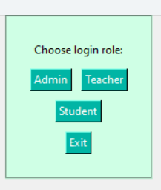

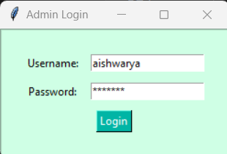

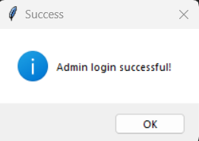

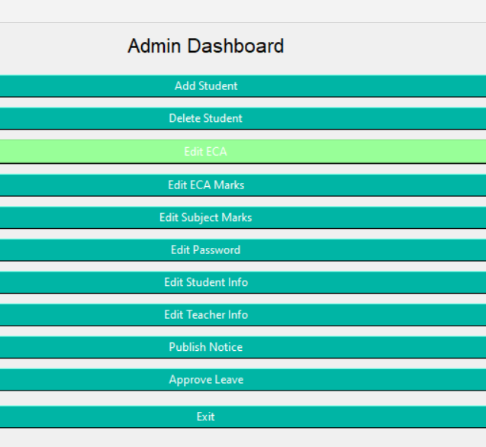

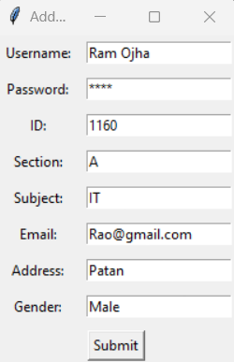
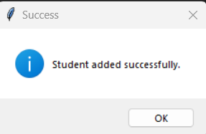

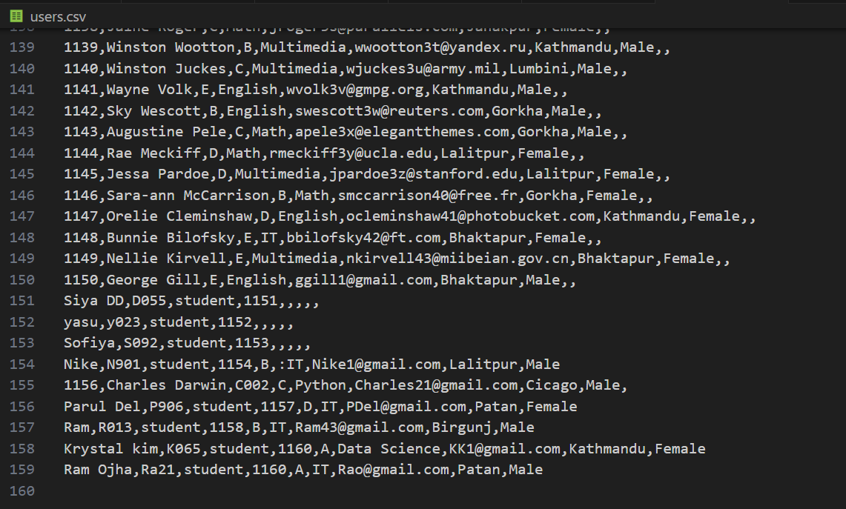

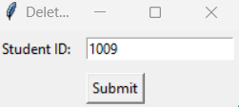

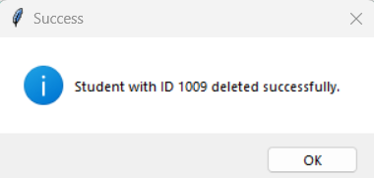

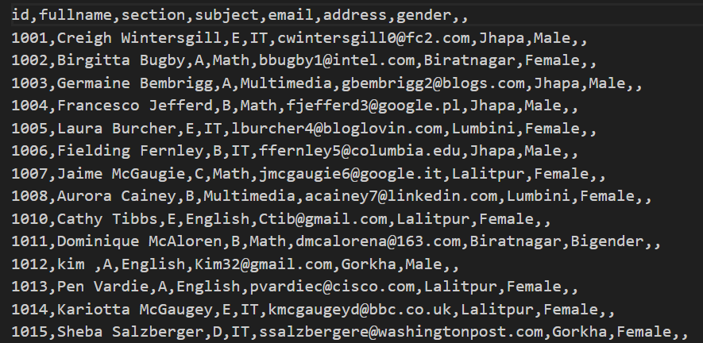

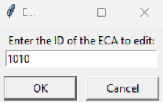

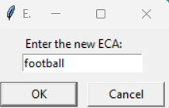
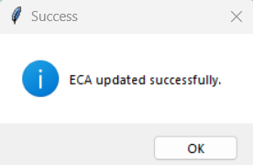

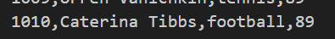

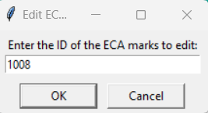

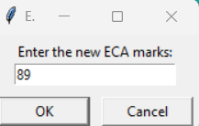
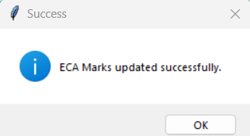

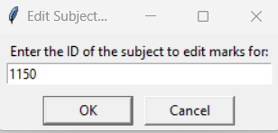
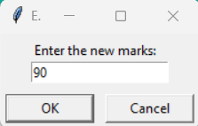
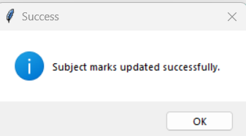

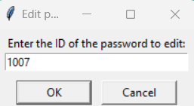
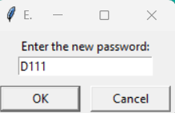
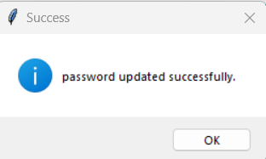

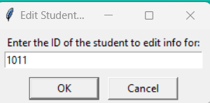
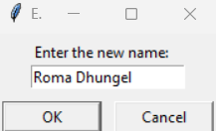
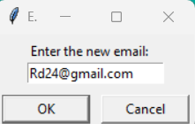
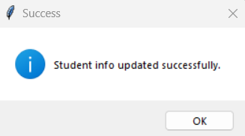
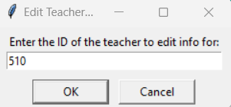
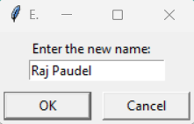
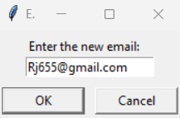
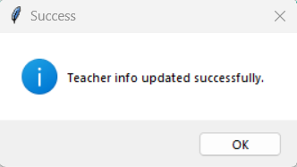

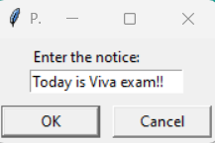

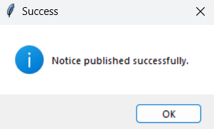
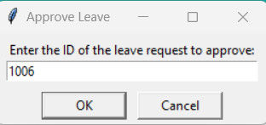

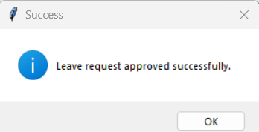
- First of user is asked to choose their log in if user wants to log in as student , Appropriate username and password should be used for log in from users.csv file in case of wrong password or username , It will show error.
- After log into student dashboard user has option to choose;
- view_personal_info()
- -view_your_grades()
- -view_top3_bottom3_ineach_subject()
- -view_top3_bottom3_overall()
- -view_average_marks()
- -view_your_eca()
- -push_leave()
- -read_notice()

- After making choice they can proceed further as given below in outputs.

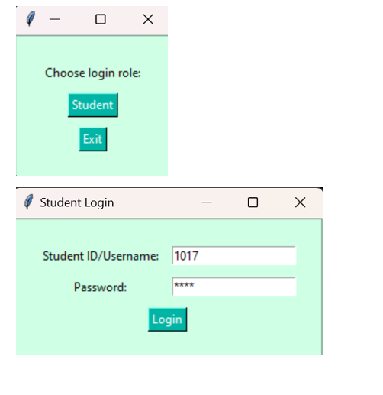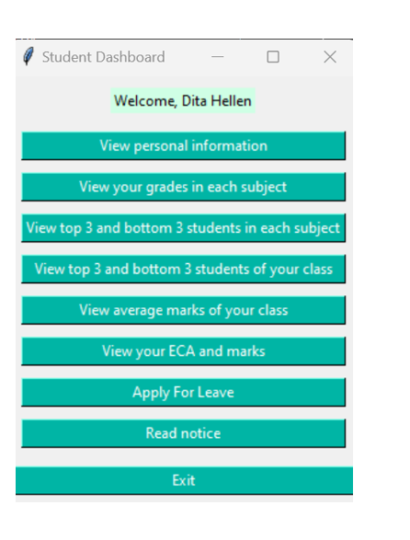
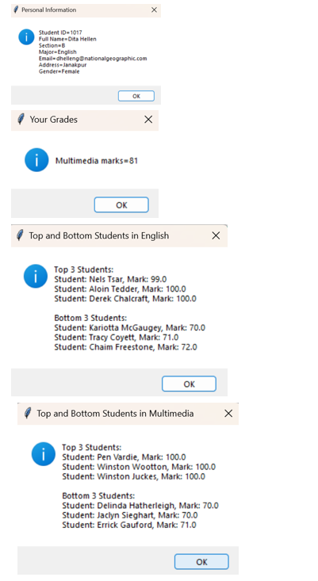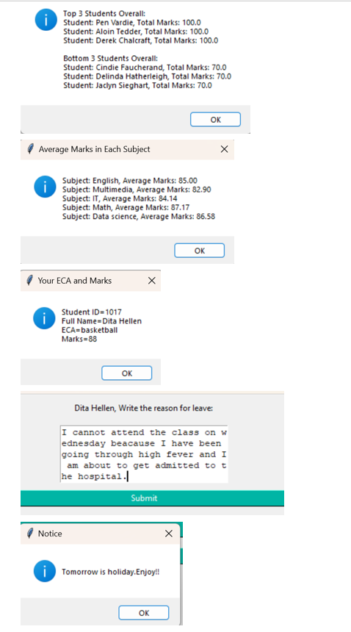

- First of user is asked to choose their log in if user wants to log in as teacher , Appropriate username and password should be use for log in from teachers.csv, in case of wrong password or username , It will show error.
- After log into admin dashboard user has option to choose ;
- View personal info,
- View ECA marks
- Edit Teacher info ,
- Publish Notice ,
- Apply Leave or Exit.
- After making choice they can proceed further as given below in outputs.
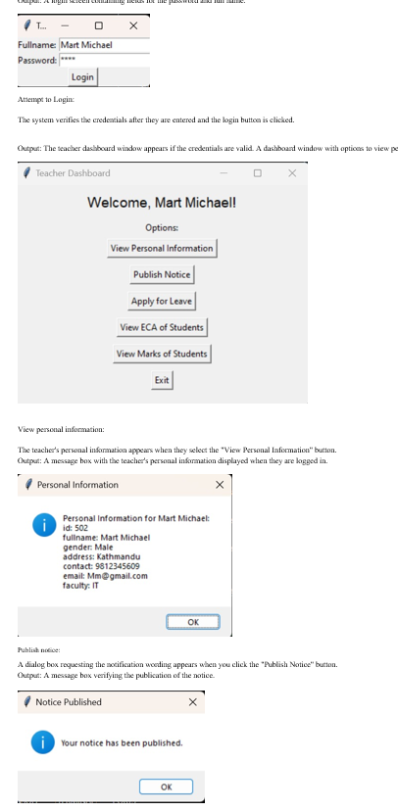
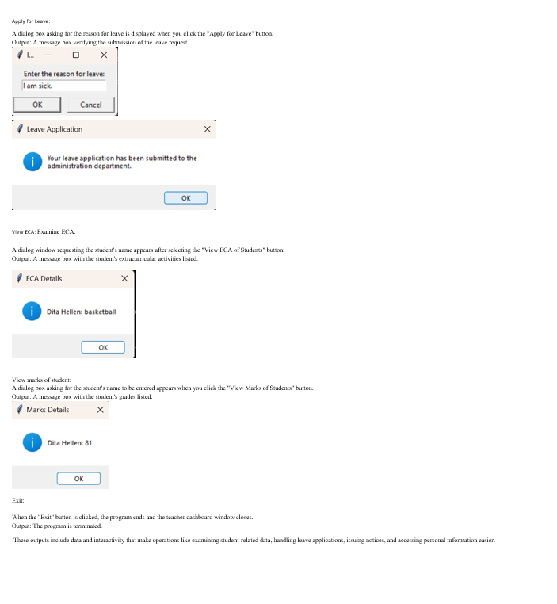

Uml diagram:
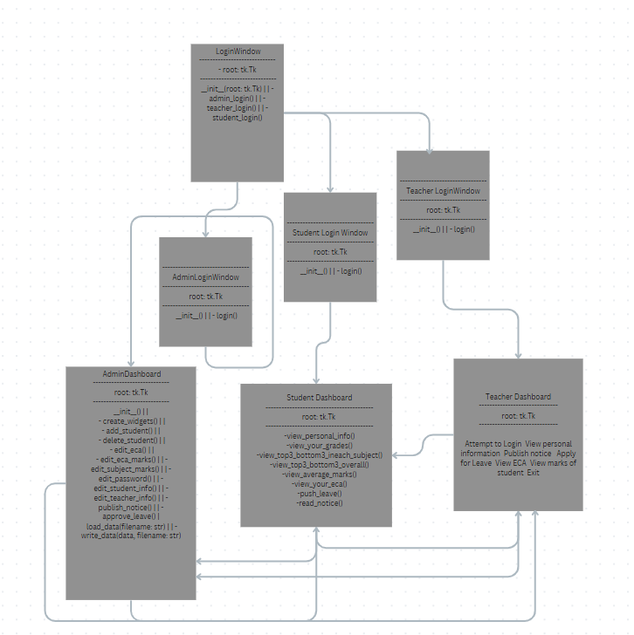
Flow chart:
+---------------------+
| Student Login |
+---------------------+
|
+-----v-----+
| Login |
| Window |
+-----+-----+
|
+--------v--------+
| Enter Credentials|
+--------+--------+
|
+-----v-----+
| Validate |
| Login |
| Credentials|
+-----+-----+
|
+--------v--------+ +-----------------------+
| Successful Login|----------> Student Dashboard |
| ? | | |
+--------+--------+ | - View Personal Info |
| | - View Grades |
| | - View ECA Details |
| | - Apply for Leave |
| | - Read Notices |
| +-----------------------+
|
v
+--------+--------+
| Failed Login |
| ? |
+--------+--------+
|
+-----v-----+
| Show |
| Error |
| Message |

+---------------------+
| Teacher Login |
+---------------------+
|
+-----v-----+
| Login |
| Window |
+-----+-----+
|
+--------v--------+
| Enter Credentials|
+--------+--------+
|
+-----v-----+
| Validate |
| Login |
| Credentials|
+-----+-----+
|
+--------v--------+ +-----------------------+
| Successful Login|----------> Teacher Dashboard |
| ? | | |
+--------+--------+ | - View Personal Info |
| | - Publish Notices |
| | - View ECA Details |
| | - View Student Marks |
| | - Apply for Leave |
| +-----------------------+
|
v
+--------+--------+
| Failed Login |
| ? |
+--------+--------+
|
+-----v-----+
| Show |
| Error |
| Message |
+---------------------+
| Main Functionality |
+---------------------+
|
+-----v-----+
| Login |
| Window |
+-----+-----+
|
+-----v-----+
| Admin |
| Login |
| Process |
+-----+-----+
|
+--------v--------+
| Enter |
| Credentials |
+--------+--------+
|
+-----v-----+
| Validate |
| Credentials|
+-----+-----+
|
+--------v--------+ +-------------------------+
| Successful Login|----------> Admin Dashboard |
| ? | | |
+--------+--------+ | - Manage Students |
| | - Manage Teachers |
| | - Publish Notices |
| | - View Student Details |
| | - View Teacher Details |
| | - Logout |
| +-------------------------+
|
v
+--------+--------+
| Failed Login |
| ? |
+--------+--------+
|
+-----v-----+
| Show |
| Error |
| Message |
+-----------+

Work Contribution:
My role is to operate as admin , role for student and teacher role are mentioned above with output.
Admin Role:
Admin Login Interface: admin login interface where the admin may input their password and username.
Admin Dashboard: Following a successful login, the admin's dashboard will be created, including features like adding and removing students.
Add Student Features: the features that allow you to add new students to the system.
Delete Student Functionality : Add the ability to remove an existing student from the system.
Edit ECA : edits and add new eca
Edit ECA Marks: edits and add new eca marks
Edit Subject marks: edits and add new subject marks
Edit Password : edits and add new password
Edit Student Info : edits student information
Edit Teacher info : edits teacher information
Publish Notice : publishes notice
Approve Leave: apply leave for student and teacher

Admin source code:
import tkinter as tk
from tkinter import simpledialog, messagebox
import matplotlib.pyplot as plt
import csv

STUDENT_DATABASE = 'students.csv'
TEACHER_DATABASE = 'teacherss.csv'
ECA_DATABASE = 'eca1.csv'
GRADES_DATABASE = 'grades.csv'

class LoginWindow:
def _init_(self, root):
self.root = root
self.root.title("Login")

self.frame = tk.Frame(self.root, bg="#CFFFE5", padx=20, pady=20, bd=2, relief=tk.GROOVE)
self.frame.pack()

self.label = tk.Label(self.frame, text="Choose login role:", bg="#CFFFE5")
self.label.grid(row=0, columnspan=2, padx=5, pady=5)

self.button_admin = tk.Button(self.frame, text="Admin", command=self.admin_login, bg="#00B5A5", fg="white", bd=1)
self.button_admin.grid(row=1, column=0, padx=5, pady=5)

self.button_teacher = tk.Button(self.frame, text="Teacher", command=self.teacher_login, bg="#00B5A5", fg="white", bd=1)
self.button_teacher.grid(row=1, column=1, padx=5, pady=5)

self.button_student = tk.Button(self.frame, text="Student", command=self.student_login, bg="#00B5A5", fg="white", bd=1)
self.button_student.grid(row=2, column=0, columnspan=2, padx=5, pady=5)

self.button_exit = tk.Button(self.frame, text="Exit", command=self.root.destroy, bg="#00B5A5", fg="white", bd=1)
self.button_exit.grid(row=3, columnspan=2, padx=5, pady=5)

def admin_login(self):
self.root.destroy()
AdminLoginWindow()

def teacher_login(self):
self.root.destroy()
TeacherLoginWindow()

def student_login(self):
self.root.destroy()
StudentLoginWindow()

class AdminLoginWindow:
def _init_(self):
self.root = tk.Tk()
self.root.title("Admin Login")

self.frame = tk.Frame(self.root, bg="#CFFFE5", padx=20, pady=20, bd=2, relief=tk.GROOVE)
self.frame.pack()

self.label_username = tk.Label(self.frame, text="Username:", bg="#CFFFE5")
self.label_username.grid(row=0, column=0, padx=5, pady=5)
self.entry_username = tk.Entry(self.frame, bd=1)
self.entry_username.grid(row=0, column=1, padx=5, pady=5)

self.label_password = tk.Label(self.frame, text="Password:", bg="#CFFFE5")
self.label_password.grid(row=1, column=0, padx=5, pady=5)
self.entry_password = tk.Entry(self.frame, show="*", bd=1)
self.entry_password.grid(row=1, column=1, padx=5, pady=5)

self.button_login = tk.Button(self.frame, text="Login", command=self.login, bg="#00B5A5", fg="white", bd=1)
self.button_login.grid(row=2, columnspan=2, padx=5, pady=5)

def login(self):
username = self.entry_username.get()
password = self.entry_password.get()

# Implement your authentication logic here for admin
if username == "aishwarya" and password == "ash@123":
messagebox.showinfo("Success", "Admin login successful!")
self.root.destroy()
AdminDashboard()
else:
messagebox.showerror("Error", "Invalid username or password")

class TeacherLoginWindow:
def _init_(self):
self.root = tk.Tk()
self.root.title("Teacher Login")

self.frame = tk.Frame(self.root, bg="#CFFFE5", padx=20, pady=20, bd=2, relief=tk.GROOVE)
self.frame.pack()

self.label_id = tk.Label(self.frame, text="Teacher ID:", bg="#CFFFE5")
self.label_id.grid(row=0, column=0, padx=5, pady=5)
self.entry_id = tk.Entry(self.frame, bd=1)
self.entry_id.grid(row=0, column=1, padx=5, pady=5)

self.label_password = tk.Label(self.frame, text="Password:", bg="#CFFFE5")
self.label_password.grid(row=1, column=0, padx=5, pady=5)
self.entry_password = tk.Entry(self.frame, show="*", bd=1)
self.entry_password.grid(row=1, column=1, padx=5, pady=5)

self.button_login = tk.Button(self.frame, text="Login", command=self.login, bg="#00B5A5", fg="white", bd=1)
self.button_login.grid(row=2, columnspan=2, padx=5, pady=5)

class Teacher(User):
def init(self, fullname, role, email=None, password=None):
super().init(fullname, role)
self.email = email
self.password = password

def teacher_login(entry_fullname, entry_password, login_window):
try:
# Prompting user for input
fullname = entry_fullname.get()
password = entry_password.get()

# Reading teacher password from CSV file
with open(TEACHER_DATABASE, mode='r') as file:
reader = csv.DictReader(file)
for row in reader:
if row['fullname'] == fullname and row['passsword'] == password:
# If the entered credentials match, call the teacher_dashboard function
login_window.destroy() # Close the login window
teacher_dashboard(fullname)
return # Exit the function if login is successful

# If the loop completes without finding a matching fullname and password
messagebox.showerror("Error", "Invalid fullname or password. Please try again.")
except FileNotFoundError:
messagebox.showerror("Error", "Teacher credentials file not found.")
except Exception as e:
messagebox.showerror("Error", f"An unexpected error occurred: {e}")

class StudentLoginWindow:
def _init_(self):
self.root = tk.Tk()
self.root.title("Student Login")

self.frame = tk.Frame(self.root, bg="#CFFFE5", padx=20, pady=20, bd=2, relief=tk.GROOVE)
self.frame.pack()

self.label_id = tk.Label(self.frame, text="Student ID:", bg="#CFFFE5")
self.label_id.grid(row=0, column=0, padx=5, pady=5)
self.entry_id = tk.Entry(self.frame, bd=1)
self.entry_id.grid(row=0, column=1, padx=5, pady=5)

self.label_password = tk.Label(self.frame, text="Password:", bg="#CFFFE5")
self.label_password.grid(row=1, column=0, padx=5, pady=5)
self.entry_password = tk.Entry(self.frame, show="*", bd=1)
self.entry_password.grid(row=1, column=1, padx=5, pady=5)

self.button_login = tk.Button(self.frame, text="Login", command=self.login, bg="#00B5A5", fg="white", bd=1)
self.button_login.grid(row=2, columnspan=2, padx=5, pady=5)

def login(self):
student_id = self.entry_id.get()
password = self.entry_password.get()

# Implement your authentication logic here for student
try:
with open("users.csv", newline='') as users_file:
reader = csv.DictReader(users_file)
for row in reader:
if row["student_id"] == student_id and row["password"] == password:
messagebox.showinfo("Success", "Student login successful!")
self.root.destroy()
StudentDashboard()
return
except FileNotFoundError:
messagebox.showerror("Error", "Student data file not found")
return
messagebox.showerror("Error", "Invalid ID or password")

class AdminDashboard:
def _init_(self):
self.root = tk.Tk()
self.root.title("Admin Dashboard")
self.create_widgets()

def create_widgets(self):
self.label = tk.Label(self.root, text="Admin Dashboard", font=("Helvetica", 16))
self.label.pack(pady=10)

self.button_add_student = tk.Button(self.root, text="Add Student", command=self.add_student, bg="#00B5A5", fg="white", bd=1)
self.button_add_student.pack(pady=5, fill=tk.X)

self.button_delete_student = tk.Button(self.root, text="Delete Student", command=self.delete_student, bg="#00B5A5", fg="white", bd=1)
self.button_delete_student.pack(pady=5, fill=tk.X)

self.button_edit_eca = tk.Button(self.root, text="Edit ECA", command=self.edit_eca, bg="#98FF98", fg="white", bd=2)
self.button_edit_eca.pack(pady=5, fill=tk.X)

self.button_edit_eca_marks = tk.Button(self.root, text="Edit ECA Marks", command=self.edit_eca_marks, bg="#00B5A5", fg="white", bd=1)
self.button_edit_eca_marks.pack(pady=5, fill=tk.X)

self.button_edit_subject_marks = tk.Button(self.root, text="Edit Subject Marks", command=self.edit_subject_marks, bg="#00B5A5", fg="white", bd=1)
self.button_edit_subject_marks.pack(pady=5, fill=tk.X)

self.button_edit_password = tk.Button(self.root, text="Edit Password", command=self.edit_password, bg="#00B5A5", fg="white", bd=1)
self.button_edit_password.pack(pady=5, fill=tk.X)

self.button_edit_student_info = tk.Button(self.root, text="Edit Student Info", command=self.edit_student_info, bg="#00B5A5", fg="white", bd=1)
self.button_edit_student_info.pack(pady=5, fill=tk.X)

self.button_edit_teacher_info = tk.Button(self.root, text="Edit Teacher Info", command=self.edit_teacher_info, bg="#00B5A5", fg="white", bd=1)
self.button_edit_teacher_info.pack(pady=5, fill=tk.X)

self.button_publish_notice = tk.Button(self.root, text="Publish Notice", command=self.publish_notice, bg="#00B5A5", fg="white", bd=1)
self.button_publish_notice.pack(pady=5, fill=tk.X)

self.button_approve_leave = tk.Button(self.root, text="Approve Leave", command=self.approve_leave, bg="#00B5A5", fg="white", bd=1)
self.button_approve_leave.pack(pady=5, fill=tk.X)

self.button_exit = tk.Button(self.root, text="Exit", command=self.root.destroy, bg="#00B5A5", fg="white", bd=1)
self.button_exit.pack(pady=10, fill=tk.X)

def add_student(self):
def submit():
username = entry_username.get()
password = entry_password.get()
student_id = entry_id.get()
section = entry_section.get()
subject = entry_subject.get()
email = entry_email.get()
address = entry_address.get()
gender = entry_gender.get()

try:
with open("users.csv", "a", newline='') as users_file:
csv_writer = csv.writer(users_file)
csv_writer.writerow([username, password, "student", student_id, section, subject, email, address, gender])

messagebox.showinfo("Success", "Student added successfully.")
add_window.destroy()
except Exception as e:
messagebox.showerror("Error", f"An unexpected error occurred: {e}")

add_window = tk.Toplevel()
add_window.title("Add Student")

label_username = tk.Label(add_window, text="Username:")
label_username.grid(row=0, column=0, padx=5, pady=5)
entry_username = tk.Entry(add_window)
entry_username.grid(row=0, column=1, padx=5, pady=5)

label_password = tk.Label(add_window, text="Password:")
label_password.grid(row=1, column=0, padx=5, pady=5)
entry_password = tk.Entry(add_window, show="*")
entry_password.grid(row=1, column=1, padx=5, pady=5)

label_id = tk.Label(add_window, text="ID:")
label_id.grid(row=2, column=0, padx=5, pady=5)
entry_id = tk.Entry(add_window)
entry_id.grid(row=2, column=1, padx=5, pady=5)

label_section = tk.Label(add_window, text="Section:")
label_section.grid(row=3, column=0, padx=5, pady=5)
entry_section = tk.Entry(add_window)
entry_section.grid(row=3, column=1, padx=5, pady=5)

label_subject = tk.Label(add_window, text="Subject:")
label_subject.grid(row=4, column=0, padx=5, pady=5)
entry_subject = tk.Entry(add_window)
entry_subject.grid(row=4, column=1, padx=5, pady=5)

label_email = tk.Label(add_window, text="Email:")
label_email.grid(row=5, column=0, padx=5, pady=5)
entry_email = tk.Entry(add_window)
entry_email.grid(row=5, column=1, padx=5, pady=5)

label_address = tk.Label(add_window, text="Address:")
label_address.grid(row=6, column=0, padx=5, pady=5)
entry_address = tk.Entry(add_window)
entry_address.grid(row=6, column=1, padx=5, pady=5)

label_gender = tk.Label(add_window, text="Gender:")
label_gender.grid(row=7, column=0, padx=5, pady=5)
entry_gender = tk.Entry(add_window)
entry_gender.grid(row=7, column=1, padx=5, pady=5)

submit_button = tk.Button(add_window, text="Submit", command=submit)
submit_button.grid(row=8, columnspan=2, padx=5, pady=5)

def delete_student(self):
def submit():
student_id = entry_student_id.get()

# Implement logic to delete student from CSV file
try:
with open("users.csv", "r") as file:
lines = file.readlines()
with open("users.csv", "w") as file:
for line in lines:
if student_id not in line:
file.write(line)

messagebox.showinfo("Success", f"Student with ID {student_id} deleted successfully.")
delete_window.destroy()
except Exception as e:
messagebox.showerror("Error", f"An unexpected error occurred: {e}")

delete_window = tk.Toplevel()
delete_window.title("Delete Student")

label_student_id = tk.Label(delete_window, text="Student ID:")
label_student_id.grid(row=0, column=0, padx=5, pady=5)
entry_student_id = tk.Entry(delete_window)
entry_student_id.grid(row=0, column=1, padx=5, pady=5)

submit_button = tk.Button(delete_window, text="Submit", command=submit)
submit_button.grid(row=1, columnspan=2, padx=5, pady=5)

def edit_eca(self):
ecas_data = self.load_data("eca1.csv")
if not ecas_data:
return

eca_id = simpledialog.askstring("Edit ECA", "Enter the ID of the ECA to edit:")
if not eca_id:
return

eca = None
for row in ecas_data:
if row['id'] == eca_id:
eca = row
break

if not eca:
messagebox.showerror("Error", "ECA ID not found.")
return

new_eca = simpledialog.askstring("Edit ECA", "Enter the new ECA:")
if not new_eca:
return

eca['eca'] = new_eca
self.write_data(ecas_data, "eca1.csv")

messagebox.showinfo("Success", "ECA updated successfully.")

def edit_eca_marks(self):
eca_marks_data = self.load_data("eca1.csv")
if not eca_marks_data:
return

eca_marks_id = simpledialog.askstring("Edit ECA Marks", "Enter the ID of the ECA marks to edit:")
if not eca_marks_id:
return

eca_marks = None
for row in eca_marks_data:
if row['id'] == eca_marks_id:
eca_marks = row
break

if not eca_marks:
messagebox.showerror("Error", "ECA Marks ID not found.")
return

new_eca_marks = simpledialog.askstring("Edit ECA Marks", "Enter the new ECA marks:")
if not new_eca_marks:
return

eca_marks['marks'] = new_eca_marks
self.write_data(eca_marks_data, "eca1.csv")

messagebox.showinfo("Success", "ECA Marks updated successfully.")

def edit_subject_marks(self):
subject_marks_data = self.load_data("grades.csv")
if not subject_marks_data:
return

subject_id = simpledialog.askstring("Edit Subject Marks", "Enter the ID of the subject to edit marks for:")
if not subject_id:
return

subject = None
for row in subject_marks_data:
if row['id'] == subject_id:
subject = row
break

if not subject:
messagebox.showerror("Error", "Subject ID not found.")
return

new_marks = simpledialog.askstring("Edit Subject Marks", "Enter the new marks:")
if not new_marks:
return

subject['marks'] = new_marks
self.write_data(subject_marks_data, "grades.csv")

messagebox.showinfo("Success", "Subject marks updated successfully.")

def edit_password(self):
password_data = self.load_data("passwords.csv")
if not password_data:
return

password_data_id = simpledialog.askstring("Edit password", "Enter the ID of the password to edit:")
if not password_data_id:
return

password = None
for row in password_data:
if row['id'] == password_data_id:
password = row
break

if not password:
messagebox.showerror("Error", "password ID not found.")
return

new_password = simpledialog.askstring("Edit password", "Enter the new password:")
if not password:
return

password['marks'] = new_password
self.write_data(password_data, "passwords.csv")

messagebox.showinfo("Success", "password updated successfully.")

def edit_student_info(self):
students_data = self.load_data("users.csv")
if not students_data:
return

student_id = simpledialog.askstring("Edit Student Info", "Enter the ID of the student to edit info for:")
if not student_id:
return

student = None
for row in students_data:
if row['id'] == student_id:
student = row
break

if not student:
messagebox.showerror("Error", "Student ID not found.")
return

# Ask for new student details
new_name = simpledialog.askstring("Edit Student Info", "Enter the new name:")
if not new_name:
return

new_email = simpledialog.askstring("Edit Student Info", "Enter the new email:")
if not new_email:
return

student['name'] = new_name
student['email'] = new_email
self.write_data(students_data, "users.csv")

messagebox.showinfo("Success", "Student info updated successfully.")

def edit_teacher_info(self):
teachers_data = self.load_data("teacher.csv")
if not teachers_data:
return

teacher_id = simpledialog.askstring("Edit Teacher Info", "Enter the ID of the teacher to edit info for:")
if not teacher_id:
return

teacher = None
for row in teachers_data:
if row['id'] == teacher_id:
teacher = row
break

if not teacher:
messagebox.showerror("Error", "Teacher ID not found.")
return

# Ask for new teacher details
new_name = simpledialog.askstring("Edit Teacher Info", "Enter the new name:")
if not new_name:
return

new_email = simpledialog.askstring("Edit Teacher Info", "Enter the new email:")
if not new_email:
return

teacher['name'] = new_name
teacher['email'] = new_email
self.write_data(teachers_data, "teacher.csv")

messagebox.showinfo("Success", "Teacher info updated successfully.")

def publish_notice(self):
notice = simpledialog.askstring("Publish Notice", "Enter the notice:")
if not notice:
return

try:
with open("notices.csv", "a", newline='') as notices_file:
csv_writer = csv.writer(notices_file)
csv_writer.writerow([notice])

messagebox.showinfo("Success", "Notice published successfully.")
except Exception as e:
messagebox.showerror("Error", f"An unexpected error occurred: {e}")

def approve_leave(self):
leave_id = simpledialog.askstring("Approve Leave", "Enter the ID of the leave request to approve:")
if not leave_id:
return

# Implement logic to approve leave request
messagebox.showinfo("Success", "Leave request approved successfully.")

def load_data(self, filename):
try:
with open(filename, newline='') as file:
reader = csv.DictReader(file)
data = [row for row in reader]
return data
except FileNotFoundError:
messagebox.showerror("Error", f"{filename} not found.")
return None

def write_data(self, data, filename):
try:
with open(filename, "w", newline='') as file:
fieldnames = data[0].keys()
writer = csv.DictWriter(file, fieldnames=fieldnames)
writer.writeheader()
for row in data:
writer.writerow(row)
except Exception as e:
messagebox.showerror("Error", f"An unexpected error occurred: {e}")

class TeacherDashboard:
def _init_(self):
self.root = tk.Tk()
self.root.title("Teacher Dashboard")

self.label = tk.Label(self.root, text="Teacher Dashboard", font=("Helvetica", 16))
self.label.pack(pady=10)

self.button_exit = tk.Button(self.root, text="Exit", command=self.root.destroy, bg="#00B5A5", fg="white", bd=1)
self.button_exit.pack(pady=10)
def teacher_login(entry_fullname, entry_password, login_window):
try:
# Prompting user for input
fullname = entry_fullname.get()
password = entry_password.get()

# Reading teacher password from CSV file
with open(TEACHER_DATABASE, mode='r') as file:
reader = csv.DictReader(file)
for row in reader:
if row['fullname'] == fullname and row['passsword'] == password:
# If the entered credentials match, call the teacher_dashboard function
login_window.destroy() # Close the login window
teacher_dashboard(fullname)
return # Exit the function if login is successful

# If the loop completes without finding a matching fullname and password
messagebox.showerror("Error", "Invalid fullname or password. Please try again.")
except FileNotFoundError:
messagebox.showerror("Error", "Teacher credentials file not found.")
except Exception as e:
messagebox.showerror("Error", f"An unexpected error occurred: {e}")

def teacher_dashboard(fullname):
dashboard_window = tk.Tk()
dashboard_window.title("Teacher Dashboard")
dashboard_window.geometry("400x300")

welcome_label = tk.Label(dashboard_window, text=f"Welcome, {fullname}!", font=("Arial", 14))
welcome_label.pack(pady=10)

options_label = tk.Label(dashboard_window, text="Options:")
options_label.pack()

view_info_button = tk.Button(dashboard_window, text="View Personal Information", command=lambda: view_personal_info(fullname))
view_info_button.pack(pady=5)

publish_notice_button = tk.Button(dashboard_window, text="Publish Notice", command=publish_notice)
publish_notice_button.pack(pady=5)

apply_leave_button = tk.Button(dashboard_window, text="Apply for Leave", command=lambda: apply_leave(fullname))
apply_leave_button.pack(pady=5)

view_eca_button = tk.Button(dashboard_window, text="View ECA of Students", command=view_eca)
view_eca_button.pack(pady=5)

view_marks_button = tk.Button(dashboard_window, text="View Marks of Students", command=view_marks)
view_marks_button.pack(pady=5)

exit_button = tk.Button(dashboard_window, text="Exit", command=dashboard_window.destroy)
exit_button.pack(pady=5)

def view_personal_info(fullname):
try:
with open(TEACHER_DATABASE, mode='r') as file:
reader = csv.DictReader(file)
for row in reader:
if row['fullname'] == fullname:
messagebox.showinfo("Personal Information", f"Personal Information for {fullname}:\n"
f"id: {row['id']}\n"
f"fullname: {row['fullname']}\n"
f"gender: {row['gender']}\n"
f"address: {row['address']}\n"
f"contact: {row['contact']}\n"
f"email: {row['email']}\n"
f"faculty: {row['faculty']}\n")
return
messagebox.showwarning("Warning", f"No personal information found for {fullname}")
except FileNotFoundError:
messagebox.showerror("Error", "Teacher database file not found.")
except Exception as e:
messagebox.showerror("Error", f"An unexpected error occurred: {e}")

def publish_notice():
notice = simpledialog.askstring("Input", "Enter the notice:")
# Write notice to a file or database
messagebox.showinfo("Notice Published", "Your notice has been published.")

def apply_leave(fullname):
reason = simpledialog.askstring("Input", "Enter the reason for leave:")
# Write leave application with fullname and reason
messagebox.showinfo("Leave Application", "Your leave application has been submitted to the administration department.")

def view_eca():
try:
fullname = simpledialog.askstring("Input", "Enter Student Name:")
with open(ECA_DATABASE, mode='r') as file:
reader = csv.DictReader(file)
eca_details = []
for row in reader:
if row['fullname'] == fullname:
eca_details.append(f"{row['fullname']}: {row['eca']}")
if eca_details:
messagebox.showinfo("ECA Details", "\n".join(eca_details))
else:
messagebox.showwarning("Warning", f"No ECA details found for {fullname}")
except FileNotFoundError:
messagebox.showerror("Error", "ECA details file not found.")
except Exception as e:
messagebox.showerror("Error", f"An unexpected error occurred: {e}")

def view_marks():
try:
fullname = simpledialog.askstring("Input", "Enter Student Name:")
with open(GRADES_DATABASE, mode='r') as file:
reader = csv.DictReader(file)
marks_details = []
for row in reader:
if row['fullname'] == fullname:
marks_details.append(f"{row['fullname']}: {row['marks']}")
if marks_details:
messagebox.showinfo("Marks Details", "\n".join(marks_details))
else:
messagebox.showwarning("Warning", f"No marks found for {fullname}")
except FileNotFoundError:
messagebox.showerror("Error", "Grades file not found.")
except Exception as e:
messagebox.showerror("Error", f"An unexpected error occurred: {e}")

class StudentDashboard:
def _init_(self):
self.root = tk.Tk()
self.root.title("Student Dashboard")

self.label = tk.Label(self.root, text="Student Dashboard", font=("Helvetica", 16))
self.label.pack(pady=10)

self.button_exit = tk.Button(self.root, text="Exit", command=self.root.destroy, bg="#00B5A5", fg="white", bd=1)
self.button_exit.pack(pady=10)

def main():
root = tk.Tk()
app = LoginWindow(root)
root.mainloop()

main()

